**IST 370**

**Lab Assignment 4 (35 points)**

**Theme: Adding the WHERE Clause to the SELECT Statement**

NOTE: You should team up with one classmate to work on this lab assignment. Only one submission is required for each 2-person team.

**Name of your teammate: _________**

Write the SQL statements for the following requests:

1. Generate a list of customers who **live in New Jersey or Georgia.**
   1. List each customer’s last name, first name, and state.
   2. Concatenate firstname and lastname into one field for output display. Use “Customer” as the column heading.
   3. Use the COLUMN … FORMAT command to set the width of the column STATE to 5 characters for query result display. In other words, it will show the entire word of ‘STATE’ instead of ‘ST:

COLUMN state FORMAT A5

* 1. Put the results **in ascending order of state**.

You can write this query in two different ways by using the mathematic comparison operator or the IN operator.

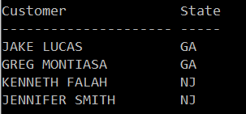

1. Find out those books that are NOT in the Fitness, Cooking, Family Life, and Computer categories. List each book title and category. Sort the output in ascending order of category. (Hint: Use the NOT IN operator)

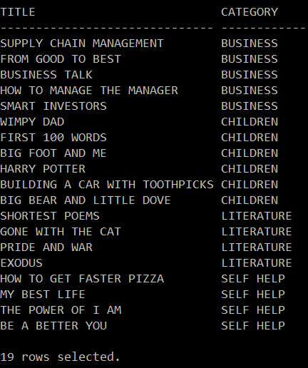

1. List those orders that were shipped **on or after June 3, 2015**? List each order number and the date it shipped. Sort the results **in ascending order of shipdate**.

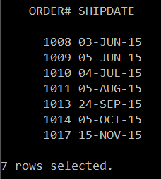

1. List all customers who were referred to the bookstore by another customer. List each customer’s last name and the number of the customer who made the referral. Sort the results in ascending order of referred.

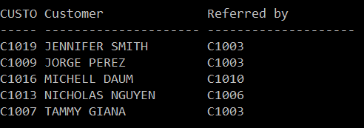

1. List those customers who were NOT referred by another customer.

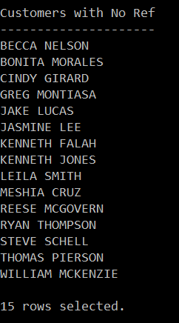

1. List the title and publish date of any computer book published in 2005. You can perform this task of searching for the publish date by using any of the following three methods:

a) a range operator: BETWEEN … AND

b) a logical operator: condition1 AND condition2

c) a search pattern operation: LIKE

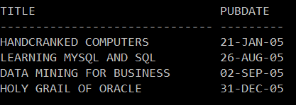

1. Generate a list of the titles of all COMPUTER books that **generate a profit of at least $10.00**. Sort the results in **descending** order of book’s profit. (Hint: **profit = retail-cost**)

